GIS Icon meanings
- The first icon from the left is our Property tax icon. If you click this it will show up as
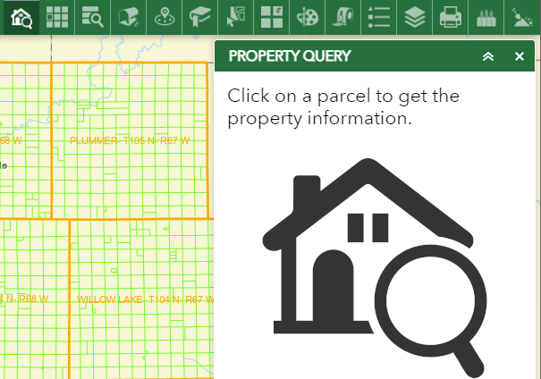
After this pop up you will need to click on the property, you are looking into.
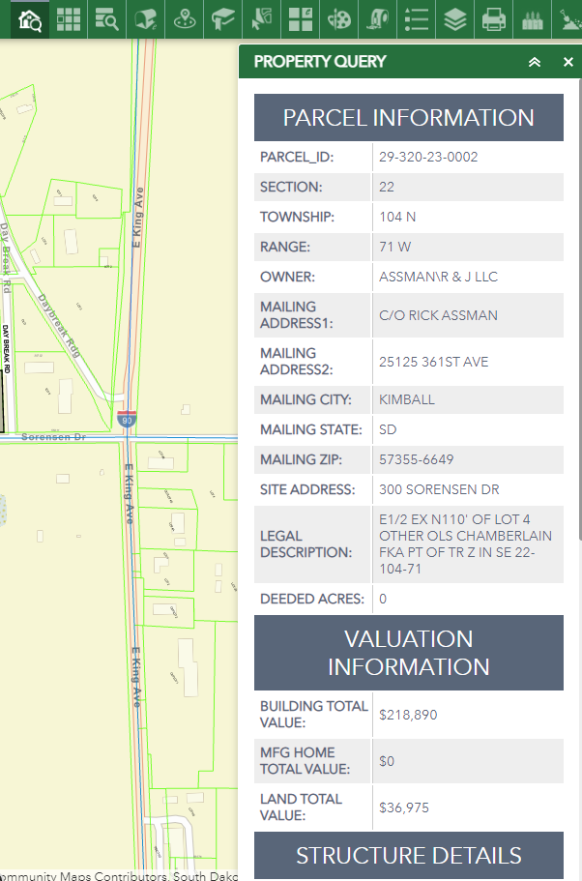

- The second icon from the left is our search for Section-Township-Range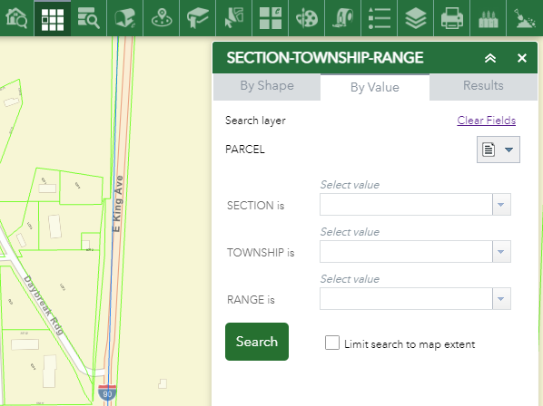
- The third icon from the left is our Advance Search option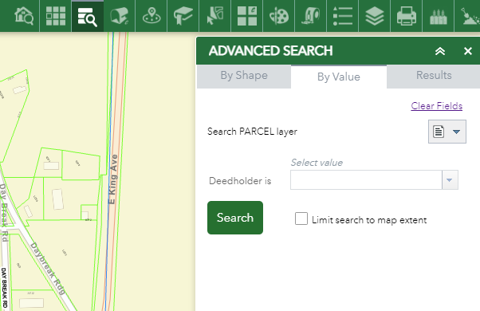
- The fourth icon from the left is our Address Inspector. If you go into any of the towns and click on a property, it will bring up the address for you.
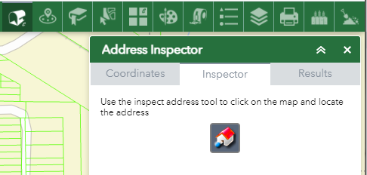
- The fifth icon from the left is our buffer icon. With this icon you are able to click on a spot on the map and it will show you everyone who owns property in the area of your subject. To get your results here are step by step instructions.
  - Once you click the icon, the following box will pop up
    - 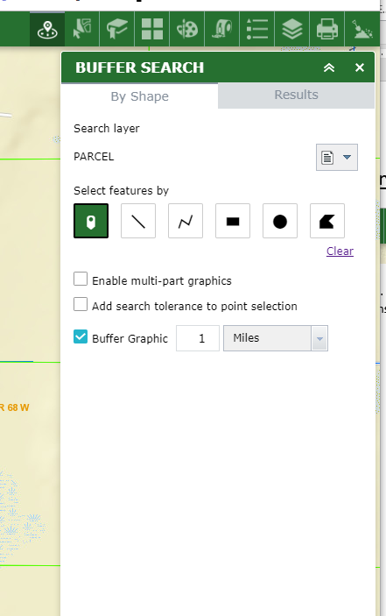
    - You will then click on the area you are looking at and the following will show
    - 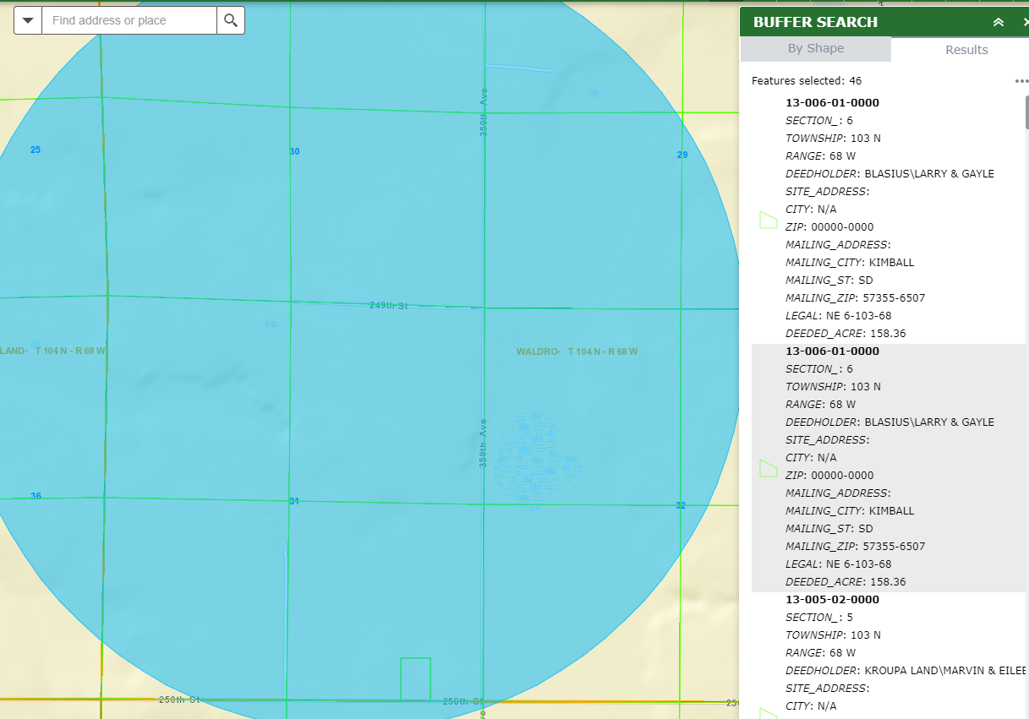
    - You can also see it in a better form if you click on the following at the bottom of your screen
    - 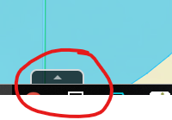

    - It will then show you all the sections, townships, names, and parcels
    - 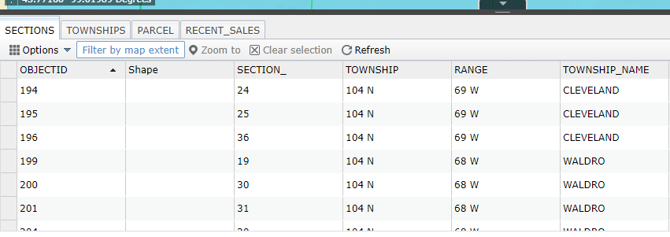
- The sixth Icon bookmarks icon. It takes you to our towns so it is easier to get to them.
- The seventh icon is our select icon. This icon is all checked marked with everything we use. You will not use this icon very much.
- The eighth icon is used quite a bit. It is where you can change from the street view to the imagery view and vice versa. You are also able to view the FSA maps from previous years.
  - 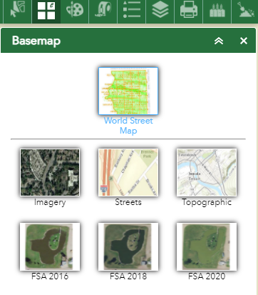

- The ninth icon is our draw icon. This one lets you draw on our map. It is where you can add symbols and points to get you from point A to point B.
  - 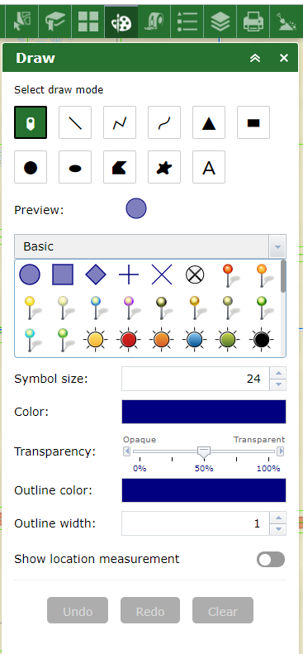

- The tenth icon is our measuring icon. This one is great because you can go and see how big a property is. Just remember when you are done measuring please use the red trash icon to get rid of it and then you can start another measurement. If you do not use that trash icon, it will continue with the measurement.
  - 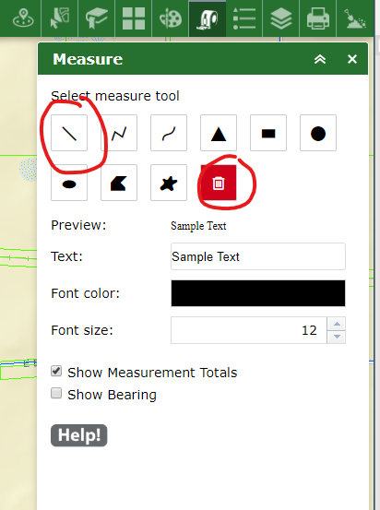

- The eleventh icon is the Legend icon. This icon tells you what certain colors on our maps are.
  - 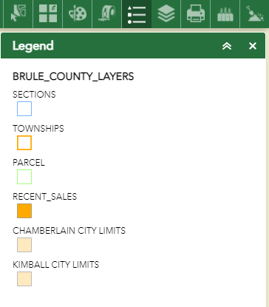
- The twelfth icon is the Layers Icon. This not the same as the other layers icon. This one you are able to get the town Annotations. If you click on the town Annotations, it will tell you the block number, the lot numbers, and the additions. This icon also shows you the city limits or the county zoning.
  - 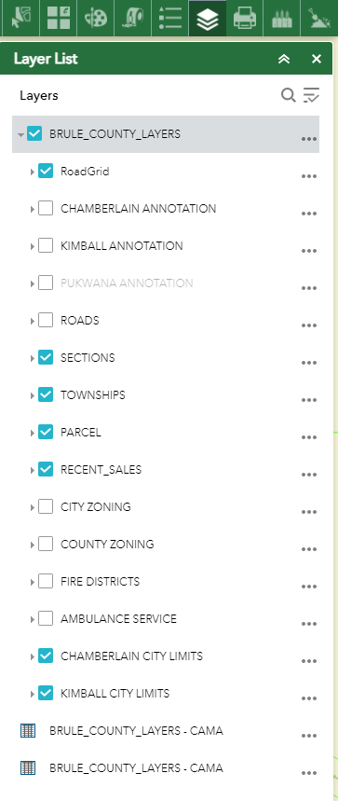

- The thirteenth icon is the Print icon. If you would like to print the picture you are seeing you are able to hit this icon and then click on the print button. If you feel this is not working fast enough for you then you are able to use CTL+P and it will bring up the image and print that way if you would like.
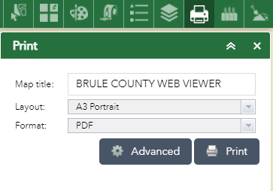

- The fourteenth icon we do not use. I am not sure how that icon works.
- The fifteenth icon is the soil report icon. This icon is used when you would like to know the soils of the land. You will click on the icon, and then find the parcel you would like to see the soils on and it will generate a report for you.
  - 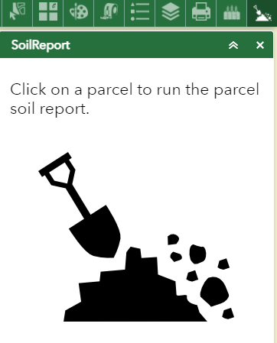

If you have questions or need more help please feel free to give us a call at
Brule County Courthouse
605-234-4432

